Sorting in the report
- Create a report
- Right click on the column header and choose Table Properties
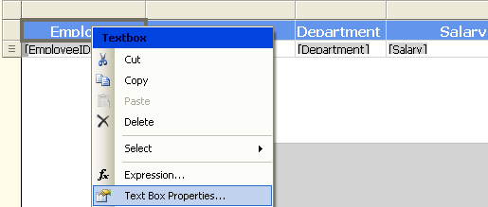
- Choose Interactive sort. And do the necessary changes. Do the same for all the columns
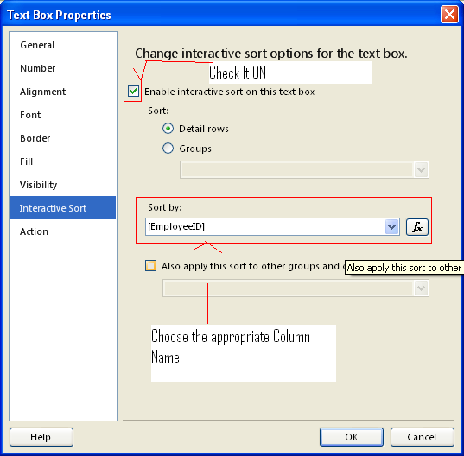

- Output
